**Year 11**

**ATAR**

**Human Biology**

|  |
| --- |
| Name: |
| Teacher: |

|  |  |  |  |
| --- | --- | --- | --- |
| **Task 9: Cell Division and Reproductive Organ Test** | | | Weighting 5% |
|  | Marks Received | Marks Available | Percentage |
| Multiple Choice |  | 18 |  |
| Short Answer |  | 35 |  |
| Extended Answer |  | 10 |  |
| Total |  | 63 |  |

Time Allocated:

Reading time: 5 minutes

Working time: 50 minutes

**PART A: MULTIPLE CHOICE SECTION (18 marks)**

1. During which stage of mitosis does DNA replication occur?

* 1. Interphase.
  2. Prophase.
  3. Metaphase.
  4. Anaphase.

2. The S phase of the cell cycle represents:

* 1. The cell at rest.
  2. DNA replication.
  3. Mitosis.
  4. None of the above.

3. Following meiosis, a germ cell may have produced four sperm cells. The total number of chromosomes in the sperm cells will be:

* 1. Four times that of the germ cell.
  2. Half that of the germ cell.
  3. Twice the number of the original germ cell.
  4. The same as the original germ cell.

4. Which of the following is the correct name for the process in which a cell splits into two smaller cells?

* 1. Karyokinesis.
  2. Metakinesis.
  3. Cytokinesis.
  4. Prokinesis.

1. If fertilisation does not occur, what is the name given to the resulting scar tissue that forms?
   1. Corpus luteum.
   2. Graafian follicle.
   3. Graafian cortex.
   4. Corpus albicans.

6. In which of the following ways are human sperm and ova similar?

a. They have approximately the same mass.

b. About the same number of each is produced.

c. They are both motile.

d. They have the same number of chromosomes.

1. The production of male sperm occurs best at:
   1. Normal body temperature, 37 °C.
   2. Above normal body temperature.
   3. Below normal body temperature.
   4. Temperatures a few degrees above or below 37 °C.

The following graph shows the development of a particular adult woman’s endometrium over the time shown. Use this graph to answer questions 8 and 9.

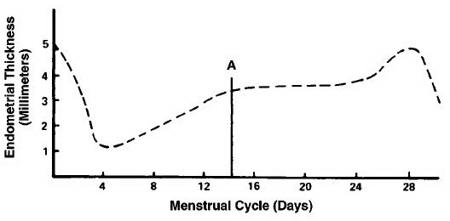

1. On which days shown on the graph did menstruation begin?
   1. Day 4.
   2. Day 1.
   3. Day 25.
   4. Day 16.
2. Ovulation from either one of her ovaries would probably have occurred around:
   1. Day 24.
   2. Day 14.
   3. Day 0.
   4. Day 4.
3. The follicle stimulating hormone (F.S.H.) stimulates the:

a. Development of the corpus luteum.

b. Production of progesterone.

c. Production and development of a mature oocyte, in the female and the production of sperm in the seminiferous tubules in the male.

d. Vascularisation of the endometrium, resulting in it becoming thickened.

1. Progesterone secretion decreases sharply near the end of the cycle because:
   1. Pregnancy occurs.
   2. Ovulation occurs.
   3. A mature follicle develops.
   4. The corpus luteum degenerates.

12. Which of the following are secondary sexual characteristics of the human female?

* + 1. Development of the ovaries
    2. Hairs growing around the genitalia
    3. Voice changes to a deeper one
    4. Broadening of the pelvic girdle
    5. Breast development

a. i and v only.

b. ii and iv only.

c. i, iii and v only.

d. ii, iv and v only.

1. Seminal fluid:

a. Provides nutrition for the ovum.

b. Causes contraction of the uterus.

c. Neutralises the acidic nature of the vagina.

d. Develops secondary sexual characteristics.

**Use the following diagram to answer question 14:**

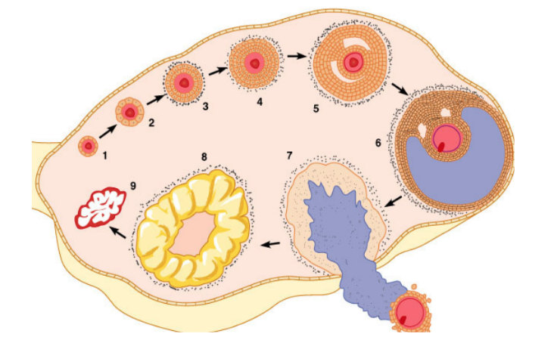

1. What is the arrow in the diagram pointing to?

* 1. The corpus luteum.
  2. A Graafian follicle.
  3. A Graafian cortex.
  4. The corpus albicans.

**Use the following diagram to answer question 15:**

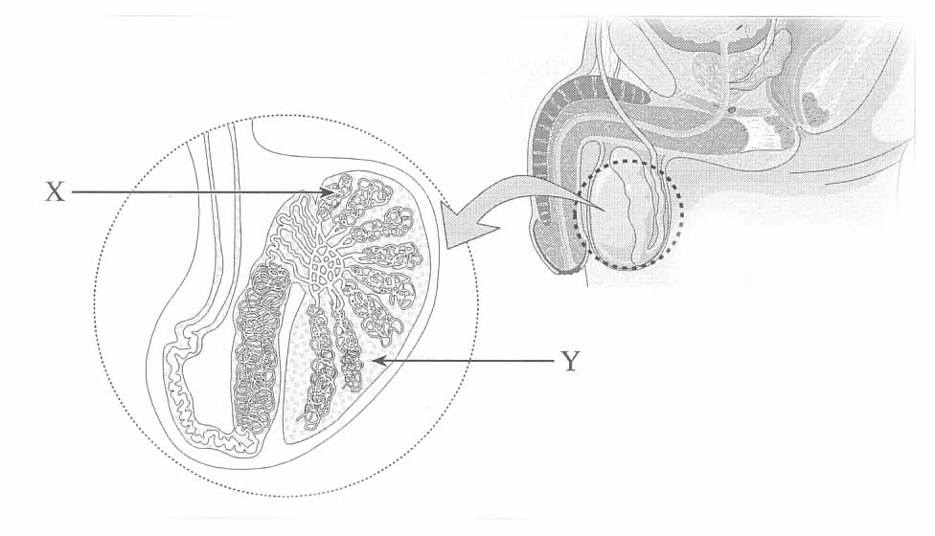

1. The function of the substance produced at **Y:**
2. Fertilises the egg.
3. Neutralises the acidity of the vagina.
4. Provides sperm nourishment.
5. Enhances muscular development.
6. The uterine tubes (Fallopian tubes) lead from the ovary to the
7. Uterus.
8. Vagina.
9. Corpus luteum.
10. Bladder.
11. What do oogonia eventually develop in to?
    1. Ovarian follicles.
    2. Ova.
    3. Ciliated epithelium.
    4. Vesicles containing enzymes.
12. Which of the following is **NOT** a part of a spermatozoa?
    1. Cell membrane.
    2. Nucleus.
    3. Lysosome.
    4. Mitochondria.

**END OF MULTIPLE CHOICE**

**Year 11**

**ATAR**

**Human Biology**

|  |
| --- |
| Name: |
| Teacher: |

**MULTIPLE CHOICE ANSWER SHEET**

For each question, shade the box to indicate your answer. Use only a blue or black pen to shade the boxes. If you make a mistake, place a cross through that square then shade your new answer. Do not erase or use correction fluid/tape. Marks will not be deducted for incorrect answers. No

marks will be given if more than one answer is

completed for any question.

|  |  |  |  |  |
| --- | --- | --- | --- | --- |
| **1** | XXXX | b | c | d |
| **2** | a | XXXX | c | d |
| **3** | a | XXXX | c | d |
| **4** | a | b | XXXX | d |
| **5** | a | b | c | XXXX |
| **6** | a | b | c | XXXX |
| **7** | a | b | XXXX | d |
| **8** | a | XXXX | c | d |
| **9** | a | XXXX | c | d |
| **10** | a | b | XXXX | d |
| **11** | a | b | c | XXXX |
| **12** | a | b | c | XXXX |
| **13** | a | b | XXXX | d |
| **14** | a | XXXX | c | d |
| **15** | a | b | XXXX | d |
| **16** | XXXX | b | c | d |
| **17** | a | XXXX | c | d |
| **18** | a | b | XXXX | d |

**PART B: SHORT ANSWER SECTION (35 marks)**

**Complete each of the following questions in the spaces provided.**

19. Mitosis and meiosis have different roles in the body. Discuss the differences between the two types of division below: (6 marks)

|  |  |
| --- | --- |
| **Mitosis** | **Meiosis** |
| One duplication of chromosomes and one nuclear division | One duplication of chromosomes and two nuclear divisions |
| Produces two diploid cells | Produces 4 haploid cells |
| Homologous chromosomes do not pair | Homologous chromosomes pair off |
| Chromatids separate so that each new cell gets a complete set of daughter cells | At first mitotic division, members of homologous pairs  separate so that new cells get a haploid set of chromosomes.  At second division,  chromatids separate, giving four haploid cells |
| Chromosomes do not change their genetic make-up | Genetic make-up of chromosomes can be changed  through crossing over |
| Produces new cells for growth and repair | Produces haploid gametes for sexual reproduction |

**MUST PROVIDE BOTH DIFFERENCES FOR EACH MARK**

20. A stem cell is an undifferentiated cell that is capable of giving rise to indefinitely more cells of the same type, and from which other types of cells arise by differentiation depending on the cells potency.

Complete the following table: (6 marks)

|  |  |  |
| --- | --- | --- |
| **Stem Cell**  **Potency** | **Can give rise to…** | **Example of where**  **stem cell can be found** |
| Totipotent | NEW ORGANISMS | FERTILISATION OF EGG / ZYGOTE |
| Pluripotent | ANY CELLS IN AN ADULT | ANY SOMATIC CELL |
| Multipotent | A SPECIFIC CELL TYPE FROM WHICH THEY ARE DERIVED | ANY SOMATIC CELL |

1. 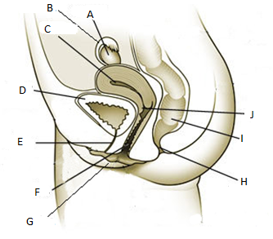Label the diagram of the female reproductive system below: (6 marks)

A - OVARY

B - OVIDUCT

C - UTERUS

E - URETHRA

F - VAGINA

J - CERVIX

22.

a) Describe the function of these male reproductive organs:

i. Epididymis (1 mark)

A HIGHLY FOLDED TUBULE THAT TRANSPORTS AND STORES SPERM IN THE TESTES, BRINGING THEM TO MATURITY

ii. Vas deferens (1 mark)

TRANSPORT SPERM AWAY FROM THE TESTIS TO BE EJACULATED

b) Which three male reproductive glands contribute to the production of semen? (1 mark)

SEMINAL VESICLES, PROSTATE AND BULBOURETHRAL GLANDS (0.5 MARK FOR 2, 1 MARK FOR ALL 3)

23. Gametogenesis is the process that produces gametes in males and females. Spermatogenesis is the process that forms male gametes, known as spermatozoa.

Oogenesis is the process that forms female gametes, known as ova.

a. How many chromosomes are found in spermatozoa? (1 mark)

23 CHROMOSOMES

b. Why is it important that spermatozoa have this chromosome number? (1 mark)

TO HAVE HALF THE CHROMOSOMAL NUMBER SO WHEN THE SPERM UNITES WITH THE OVA, IT HAS 46 CHROMOSOMES TO CREATE A HUMAN

c. What is the advantage of producing one viable ovum and three polar bodies? (1 mark)

IT REDUCES THE OVA CHROMOSOME NUMBER BY HALF – THE ONE OVUM ALSO RECEIVES ALL THE NUTRIENTS

d. Complete the table below, which outlines the differences between the processes of spermatogenesis and oogenesis? (3 marks)

|  |  |  |
| --- | --- | --- |
|  | **SPERMATOGENESIS** | **OOGENESIS** |
| Age of individual when the  process starts occurring | PUBERTY | STARTS IN THE FOETAL STAGE  – 7 WEEKS |
| Number of gametes  produced for each cell that undergoes the process | FOUR | ONE |
| Size of the products | 0.06 MM LONG | 0.1 – 0.2 MM IN DIAMETER |

**MUST PROVIDE BOTH DIFFERENCES FOR EACH MARK**

24. Complete the table below for the female reproductive system: (8 marks)

|  |  |  |  |
| --- | --- | --- | --- |
| Hormone | Where is it produced | Organ targeted | Effects |
| FSH | *Pituitary Gland* | FOLLICLES OF OVARIES | PRODUCTION OF SPERM / OVARIAN FOLLICLES |
| LH | PITUITARY GLAND | *Ovaries* | STIMULATES SECRETION OF OESTROGEN / PROGESTERONE |
| Oestrogen | OVARIAN FOLLICLE AND CORPUS LUTEUM | VARIOUS FEMALE ORGANS (UTERUS, OVARY, BRAIN) | *Stimulate the growth and repair of the endometrium.*  *Produces secondary female characteristics* |
| Progesterone | CORPUS LUTEUM | *Endometrium of the uterus* | MAINTENANCE OF ENDOMETRIUM, DEVELOPMENT/MAINTENANCE OF PLACENTA, DEVELOPMENT OF MILK-SECRETING GLANDS |

**1 EFFECT = HALF MARK, 2 OR MORE EFFECTS = FULL MARK**

**PART C: EXTENDED ANSWER SECTION (10 Marks)**

25. a) Cellular replication is essential in both growth and repair of the human body. There are 6 phases in which a cell undergoes replication. Name each phase, describe the events occurring at each phase and include a diagram for each phase to support your explanation.

(6 marks)

b) Cancer is a growth known to expand based on an uncontrolled division of cells. The health implications caused by cancer are severe and early detection can inhibit future complications. List one of Australia’s most common type of cancers, its screening process and two preventative strategies against this type of cancer.

(4 marks)

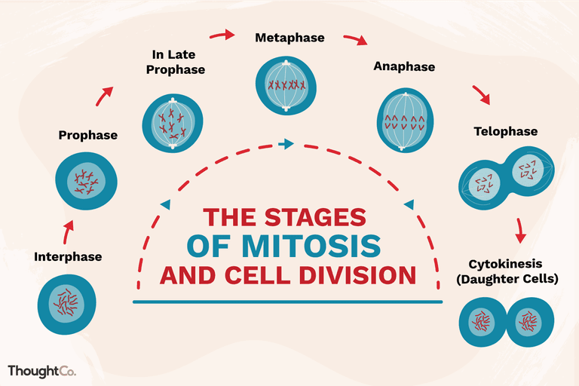

Interphase: synthesis / replication of DNA in cells

Prophase: centrioles become visible and move towards poles, microtubules form from centrioles, nucleolus disappears and nuclear membrane begins breaking down, chromatin threads tightly coil into chromosomes

Metaphase: chromatids line up at equator and centromere attach to spindle fibre

Anaphase: chromatids separate at the centromere, becoming chromosomes. They are then pulled towards opposite poles of the cell

Telophase: sets of chromosomes form tight groups at each pole, nuclear membrane reforms, nucleolus appears, spindle fibres disappear, chromosomes uncoil into chromatin threads

Cytokinesis: cytoplasm divides, furrow develops and eventually cleaves, dividing a single parent cell into two daughter cells

**2/3 COMPLETED CORRECTLY = HALF MARK, 3/3 CORRECT = FULL MARK**

* + 1. Cervical cancer, Pap smear

Breast cancer. Breastscreen

Bowel cancer, faecal occult blood test (FOBT)

Prostate cancer, digital rectal examination (DRE), prostate-specific antigen (PSA) and biopsy



**END OF TEST**